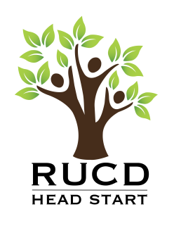

REGISTRATION CHECKLIST for Prenatal Mothers

- Review applicable sections in Parent Handbook, including
- Early Education
- Early Language Gap
- Health Screenings & Exams
- Behavioral Health
- Home Visit & Socialization
- Parents as Advocates/Leaders
- Policy Council
- Parent Engagement
- Volunteers
- Transportation & Safety
- Policies & Professional Boundaries

2. Discuss and complete:

- EHS PN.03 Information Form. Check to make sure this information matches ChildPlus.
- EHS PN.02 Service Plan
- EHS PN.04A Health Assessment (At Enrollment)
- PN.05 Dental Exam
- FCP.11 Program Information Report – Family Sheet
- FCP.12a Family Partnership Step 1
- FCP.25 Child Protection Policy
- MH.03 Mental Health Resource Sheet
- PE.01 Theme of the Month
- PE.05 Parent Engagement Activity Form
- PE.08 Parent Committee Questionnaire

3. Document registration completion date in ChildPlus under the Family Services tab. Click on Add Event and select Registration. Enter the participants name in the description line.

Rev Jun-17

